Jogging Logs/ August 8 - 14
KINE-1113-Physical Fitness
Professor Dodson
Shaquire Dean
14th August 2021

9th August 2021 Jogging Screenshot
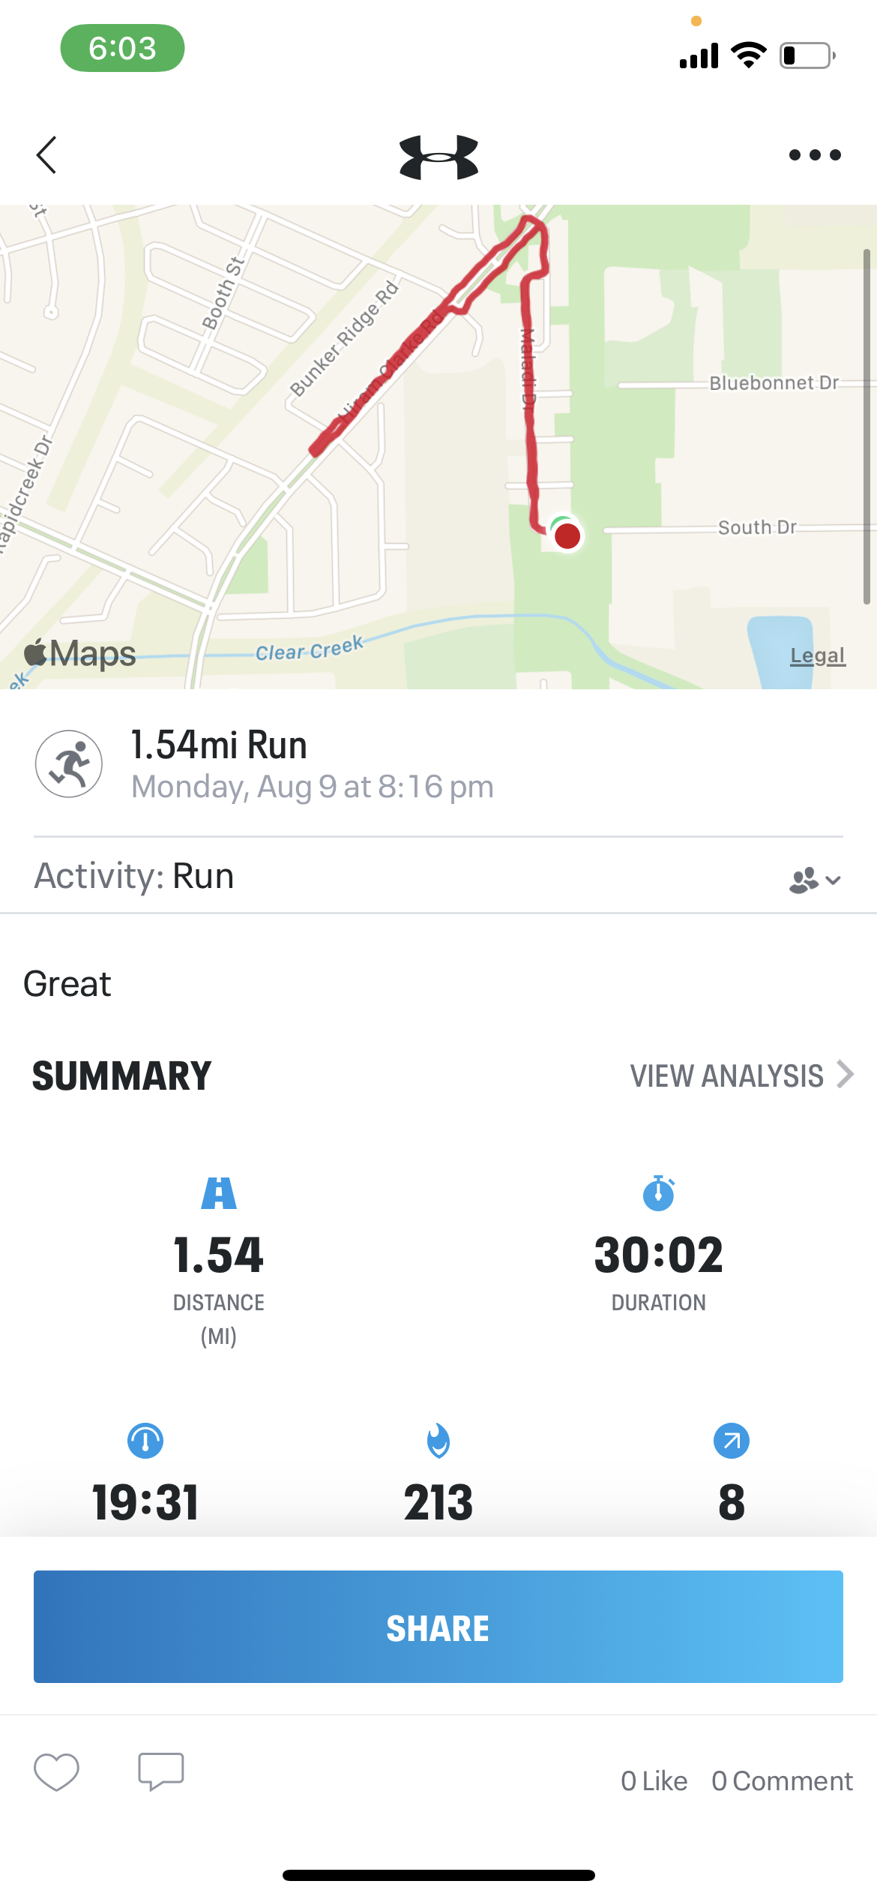
11th August 2021 Jogging Screenshot
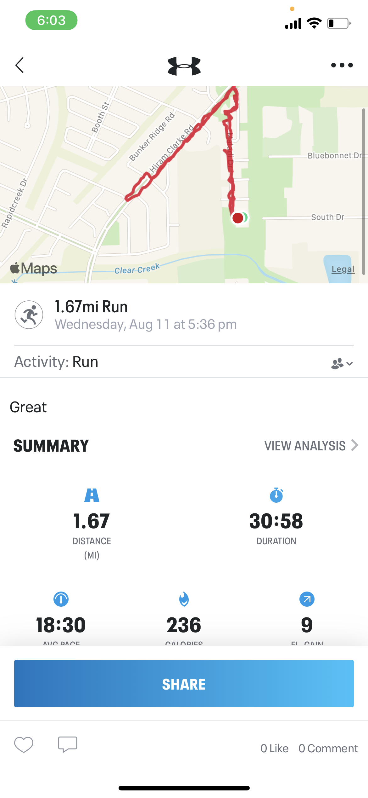

14th August 2021 Jogging Screenshot
